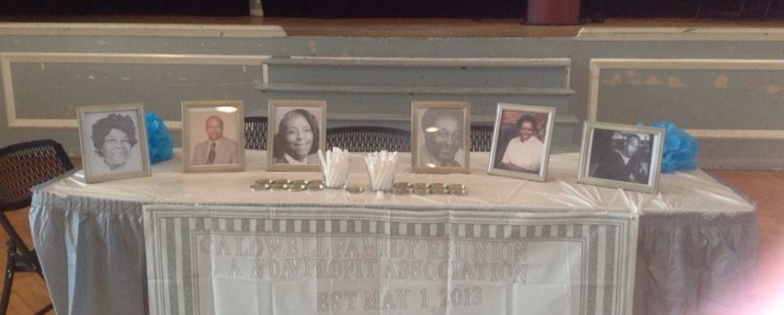 |  | Caldwell Family Reunion  - 2013 Recap  Family, I thank each of you for your support and love; and for 2 awesome reunions this year!  Samantha Perry 2013 Away Chair
In memoriam Murlee Caldwell Owens and children (Deceased) |  | Written By Sam Perry for caldwells now & to come

Destination Adventure
Away Reunion 2013 Universal Studios Orlando, FL

ion
November 26th the Tates, Perrys, and Jarretts headed out-- van and car full--with anticipation of the miles and Thanksgiving holiday traffic that laid ahead-- as we headed from Durham, NC to Orlando, FL. Our estimated 10 hour journey proved the adventure we anticipated with 2 onlooker traffic accident delays and one abrupt bumped signaling a flat tire. Thankfully we arrived, albeit 14 hours later, safe and sound.
Met by a pleasant view of palm trees and on site shopping at Westlake Vacation Villas and a quite sidewalk lined community of private homes at Cumbrian Villas we know we had arrived and made excellent accommodation choices. This would be a comfortable adventure.
Thanksgiving Day kicked off the reunion with family dinner provided and tastily prepared by Charity Philips, great granddaughter of McGrady ‘Mae’ Perry and Charity’s special friend Joshua Neptune. Charity, Josh and his family and friend started their adventure in Orlando on the 11/23.
That evening found some of us taking a well-deserved break; and the rest of the family ferrying across Downtown Disney, then strolling back taking in the sights and sounds. The remaining days were spent at each family’s leisure--visiting Universal Studios, Islands of Adventure, Sea World, and Busch Gardens. Of course other members opted to join the shopping crowd for Black Friday and great flea market deals. While others took in the city.
It was a wonderful adventure of family fellowship and fun! Thankfully we all returned by 12/2 safely and joyous to have spent a beautiful holiday and vacation with family.
The best adventure was the journey of being together.
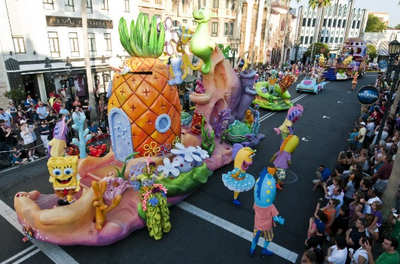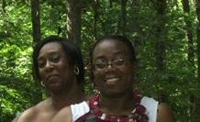
Universal Superstar Parade
1st Cousins True
L- Tabitha Michelle Walker, daughter of Ella Walker
R- Tamaira Oleisa Greene, daughter of Charity Greene
Granddaughters of ‘Mason’ McGrady Perry McPhatter
2012 Local Reunion
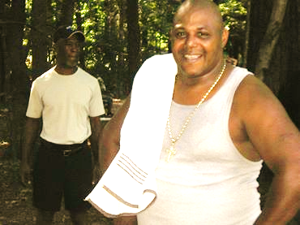
Cousins TOO or 2
L- Booker T. Tate son of Theo Caldwell Tate
R- David Bracey husband of T. Khadeedra Drakeford, granddaughter of Murlee Caldwell Nivens
(3 pic IN MEMORIUM photo above)
Booker and David are 2nd Cousins by marriage
2012 Local Reunion
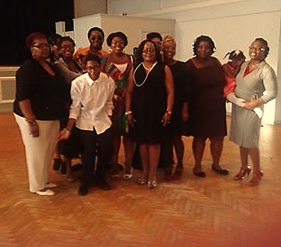

2014 Officers

President
Tamaira Greene lady27704@yahoo.com
(Far Right)

Vice President
Esther Perry dishwasher32000@yahoo.com
(Left)

Treasurer
Jan Perry twilight_sparkle@yahoo.com
(2nd from Right)

Secretary
Shari Greene greeneshari@gmail.com
(3rd from Right)

Sergeant at Arms
Descendants of ‘Mason’ McGrady Perry McPhatter
2013 Local Reunion Banquet
Teretha Tate travares@hotmail.com

2014 Chair Local Reunion
Chanda Caldwell Jarrett crc66287@msn.com

2014 Chairs Away Reunion in 2015
Shari Greene greeneshari@gmail.com
Jan Perry twilight_sparkle@yahoo.com

Local Reunion Banquet

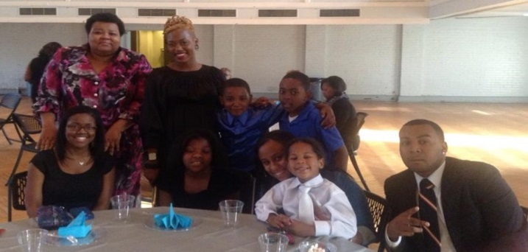
2013 Local Reunion featured our first banquet as envisioned by Chair Sanders ‘Uncle Bubba’ Tate, son of Theo Caldwell Tate. Complete with family introductions, photos, talent show, and a meal to remember, the banquet was a treat.
All the ladies sparkled and glowed in their dresses. And the men, young and ‘wise’, were just dashing in their Sunday best.
The banquet was also the venue for the annual meeting where the 2014 local and away reunion committee chairs where elected. Additionally, the family voted to host the away reunion biennially with the next trip in 2015.
Top left- Teretha Tate Cunningham (standing) w/Tairran Shari Greene (standing in black). Others are Teretha’s children, grandchildren and family friends. Top right Sanders ‘Uncle Bubba Tate son of Theo Caldwell Tate. Bottom Right-Shawn Higgins (jacket) son of Bruce Caldwell w/ wife Lynsondra (pink) and brother in law Tony Outlaw and niece Kaiya (Husband and daughter of Crystal Outlaw). Bottom Left- John Jarrett w/wife Chanda Caldwell Jarrett, daughter of Bruce Caldwell, and son Hezekiah.

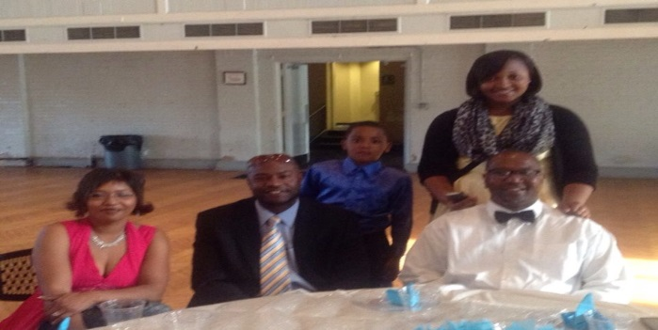

Fast Facts

Local Reunion

Meet & Greet and Picnic

What’s in a name?
“Murlee,” our matriarch’s name has been misspelled and varied throughout the ages on numerous ‘official’ documents. In fact I didn’t think there could be anymore variations yet I just found new one last week---Mariel!?!? Here are a few others: Muriel, Murielle, Mary Lee, Murlie, Murrell, and Myrtle. And of course there is the maiden name quandary--- Fisher, Harris, or Sumler?
But no matter what the spelling, to most of us she will always be Grandma and Mother Owens.

A Day in Caldwell History:
December 6th
This day in Caldwell History marks the marriage of Charlie and Murlee in 1920 and the birth of their second child Murlee ‘Baby Doll” Caldwell in 1926.

For More History and Fun Facts
Or share stories and memories

Email: Caldwell Family Reunion Family Tree

Sam Perry
Genealogical Researcher

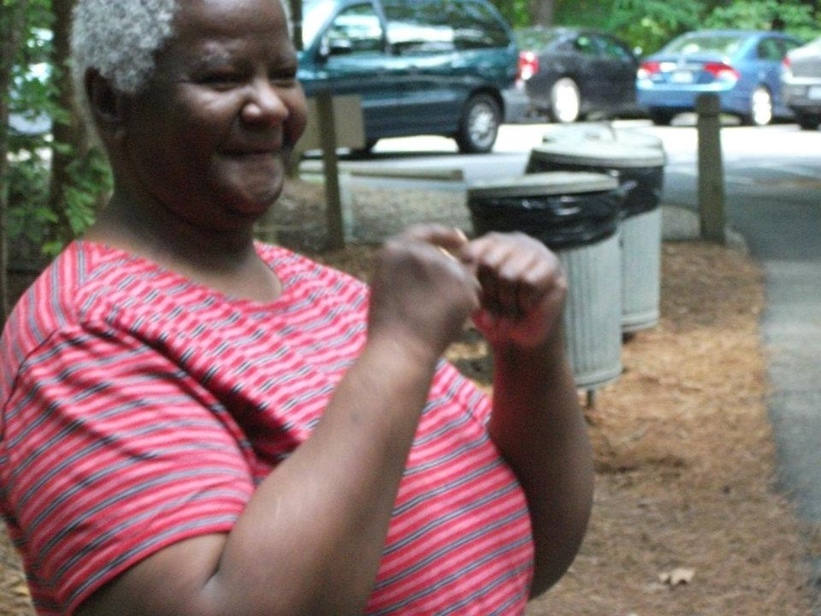
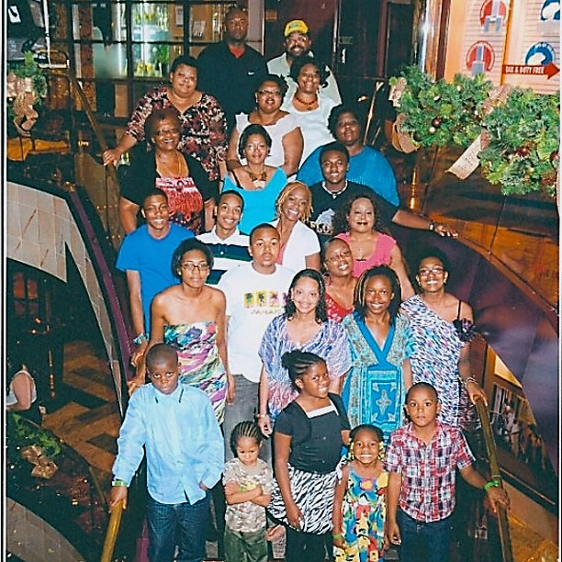
Top left - 2012 Local Reunion Theola Tate, daughter of Theo Caldwell Tate, Top Right -2013 Local Reunion Tamaira, Charity and T. Shari Greene with Theo Caldwell Tate (oldest living Caldwell age 83). Center-2012 Away Reunion Cruise to Jamaica/Grand Cayman on Carnival’s Destiny
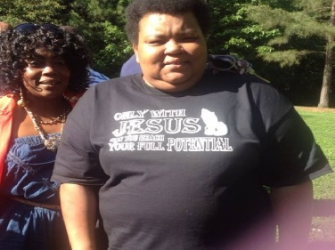
2013 Memorial Day Weekend Local Reunion was a time to enjoy the Caldwell family. “CELEBRATE 2013!” the overall event theme was a call to recognize and appreciate all things Caldwell.
For a lot of us that meant getting to know one another as the individuals we are now and the hopes and dream of who were are to be. This was the purpose of planned activities and activity’s theme, “Getting to Know You”.
The Meet and Greet kicked off interacting with one another in a casual atmosphere. The Picnic with the getting to know you questionnaire and interactive activities helped bring teamwork and the different generations together. And the Banquet to instilled closeness through fellowship and the sharing of gifts and talents with each other, honoring our love ones gone before us, celebrating the legacy they left with us.
L- Equila Drakeford granddaughter of Murlee Caldwell Nivens
R- Teretha Tate Cunningham granddaughter of Theo Caldwell Tate
And that legacy was poignantly reflected in the reunion tag line ‘Caldwell Family-Planted in love, Rooted in faith.’ This commitment to loving, believing, and helping family was the inspiration to our donation of home goods to Genesis Home.

